Project Design Phase-II
Data Flow Diagram & User Stories
Date | 28 September 2026
Team ID | 6ab221d587602313e82c60c9
Project Name | Import Data using Transform Maps (Spreadsheet)
Maximum Marks | 4 Marks
Data Flow Diagrams:
A Data Flow Diagram (DFD) is a traditional visual representation of the information flows within a system. It shows how data enters and leaves the system, what changes the information, and where data is stored. The DFD below shows how a spreadsheet is imported into ServiceNow using Import Sets and Transform Maps.
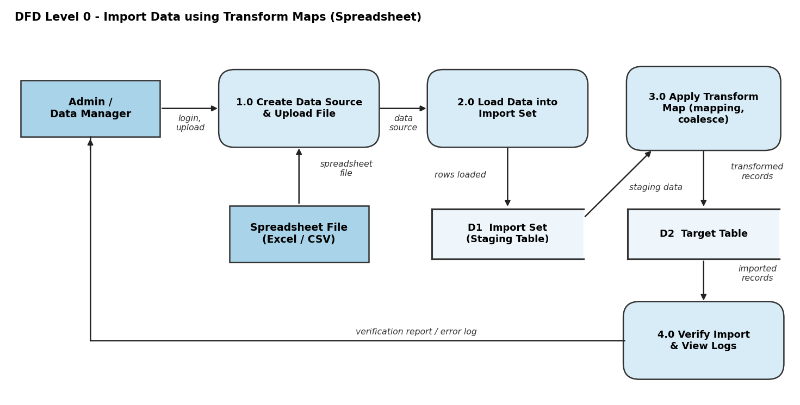
Flow:
1. Admin logs in to ServiceNow and creates a Data Source, uploading the spreadsheet (Excel / CSV).
2. Data is loaded into the Import Set staging table (D1).
3. The Transform Map maps fields, applies coalesce and scripts, and writes records to the target table (D2).
4. Admin verifies the imported records and reviews the transform history / error log.

User Stories
Use the below template to list all the user stories for the product.
User Type | Functional Requirement (Epic) | User Story Number | User Story / Task | Acceptance criteria | Priority | Release
Administrator | Spreadsheet Data Source Creation | USN-1 | As an admin, I can create a Data Source and upload an Excel (.xlsx) file so that the data can be imported. | File is uploaded and attached to the Data Source record | High | Sprint-1
 |  | USN-2 | As an admin, I can upload a CSV file as a data source. | CSV file is accepted and parsed correctly | Medium | Sprint-1
 | Import Set Loading | USN-3 | As an admin, I can load the spreadsheet data into an Import Set staging table. | All spreadsheet rows appear in the staging table | High | Sprint-1
 |  | USN-4 | As an admin, I can preview the loaded rows before running the transformation. | I can view row count and values in the Import Set | Medium | Sprint-2
Data Manager | Transform Map Configuration | USN-5 | As a data manager, I can create a Transform Map from the staging table to the target table. | Transform Map is saved with correct source and target tables | High | Sprint-2
 |  | USN-6 | As a data manager, I can map source fields to target fields. | Each spreadsheet column maps to the correct target field | High | Sprint-2
 |  | USN-7 | As a data manager, I can set a coalesce field so duplicate records are not created. | Existing records are updated instead of duplicated | Medium | Sprint-2
 | Data Transformation & Import | USN-8 | As a data manager, I can run the Transform Map to insert / update records in the target table. | Records are created / updated in the target table | High | Sprint-3
 |  | USN-9 | As a data manager, I can use a transform script to clean data (trim, format). | Imported data is clean and correctly formatted | Low | Sprint-3
 | Import Verification & Logging | USN-10 | As a data manager, I can view transform history and error logs. | Successful, skipped and failed rows are listed | Medium | Sprint-3
Business User |  | USN-11 | As a business user, I can view the imported records in the target table so that I can use the updated data. | I can see all imported records in the target table list | Medium | Sprint-3

